Messy Kitchen  Pots  Pans  Utensils  Bowls  Watering cans/jugs/cups  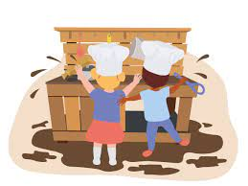 | Small World  Dinosaurs  Cars  Trucks  Train set  Teddy bears  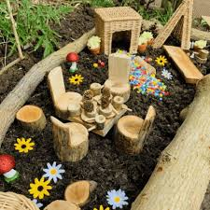  Dolls  My Little Pony  Farm Animals  Sylvanian Families | Arts & Craft  Rolls of wallpaper  Paint  Brushes  Crayons  Colouring books  Felt tips  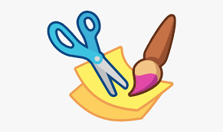  Duvets  Duvet cases  Saris
Construction  Plastic crates  Bread trays  Fruit & Veg crates  Cardboard boxes, especially large ones  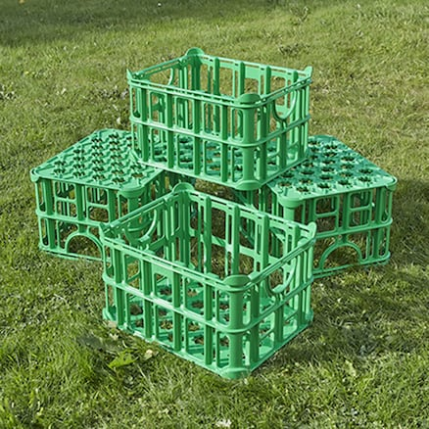  Cardboard tubes  Curtains  Carpet  Shower curtains  Hard hats  Hi-vis jackets | Roleplay  Dressing up clothes  Adult clothes  Hats  Handbags  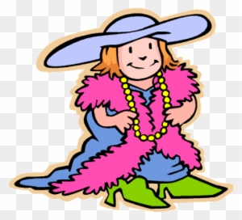  Microphones  Shoes  Work uniforms  Telephones  Shop tills  Old laptops | Low-level Wheels  Scooters  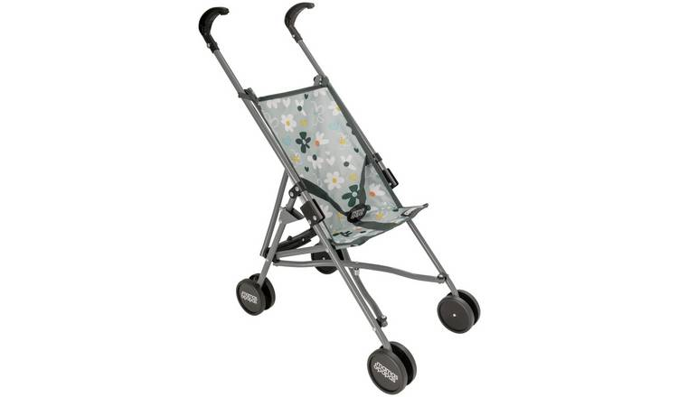  Trikes  Bikes  Balance bikes  Ride-on vehicles  Prams  Pushchairs  Suitcases with wheels  Bread trays with wheels  Go carts

